**z SAVEETHA SCHOOL OF ENGINEERING**

**SAVEETHA INSTITUTE OF MEDICAL AND TECHNICAL SCIENCES**

**INSTITUTE OF COMPUTER SCIENCE ENGINEERING**

**MANAGEMENT INFORMATION SYSTEMS**

**K.VENKATA TEJASRI**

**192111682**

**1)Payroll System**

**FORM:**

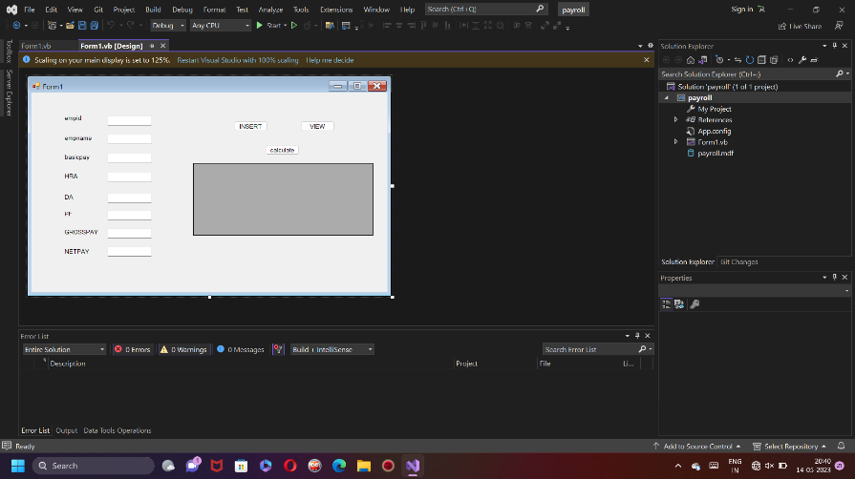

**DATABASE:**

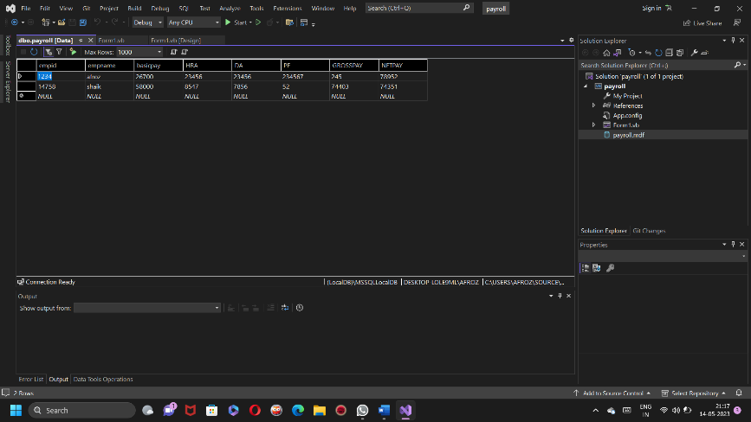

**CODE:**

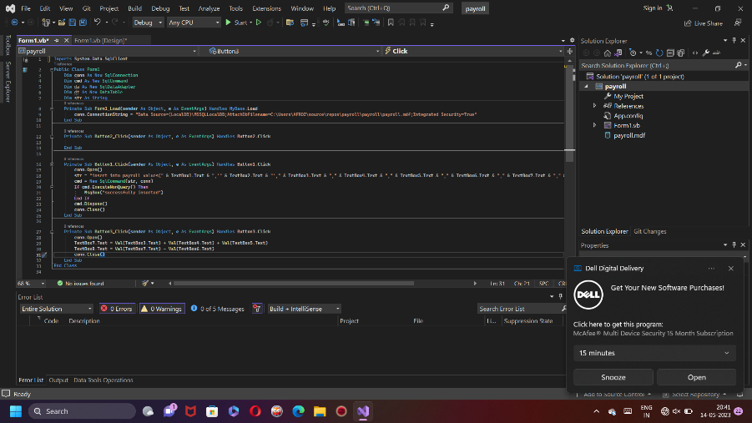

**OUTPUT:**

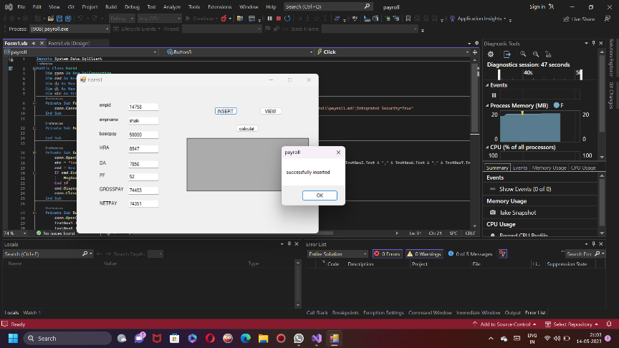

**2)STUDENTS MARKSHEET**

**FORM:**

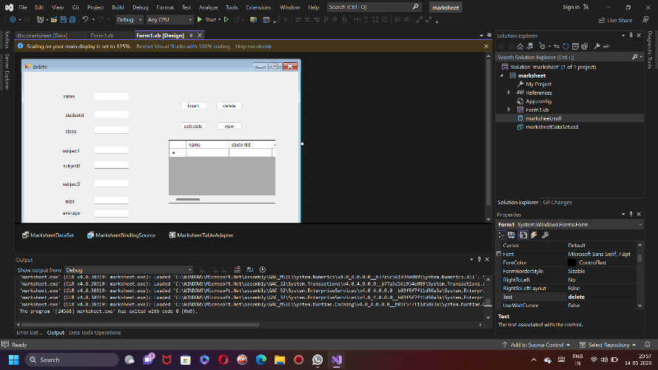

**DATABASE:**

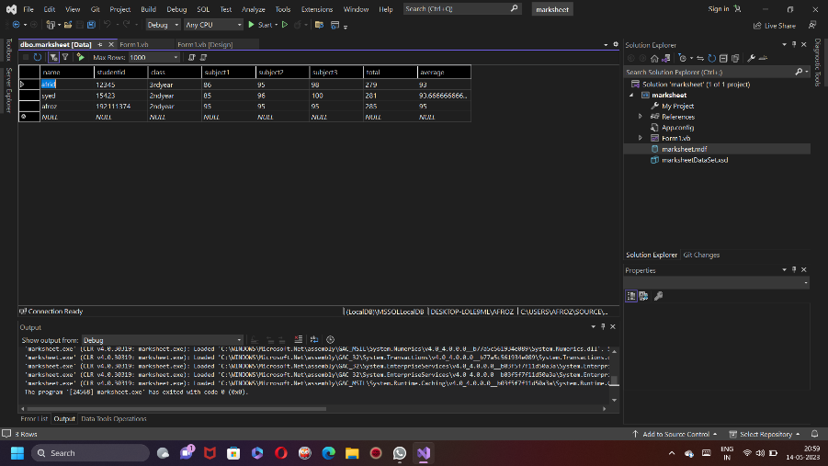

CODE:

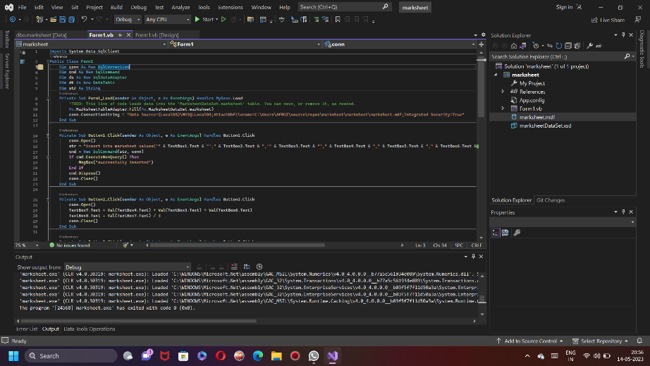

OUTPUT:

